Sign up page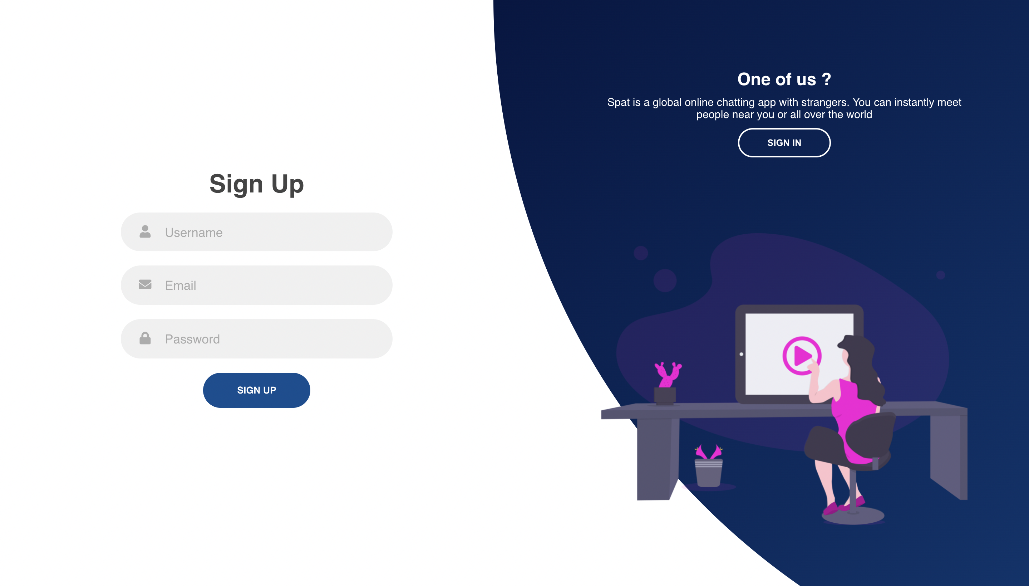

Enter email id and password and username to login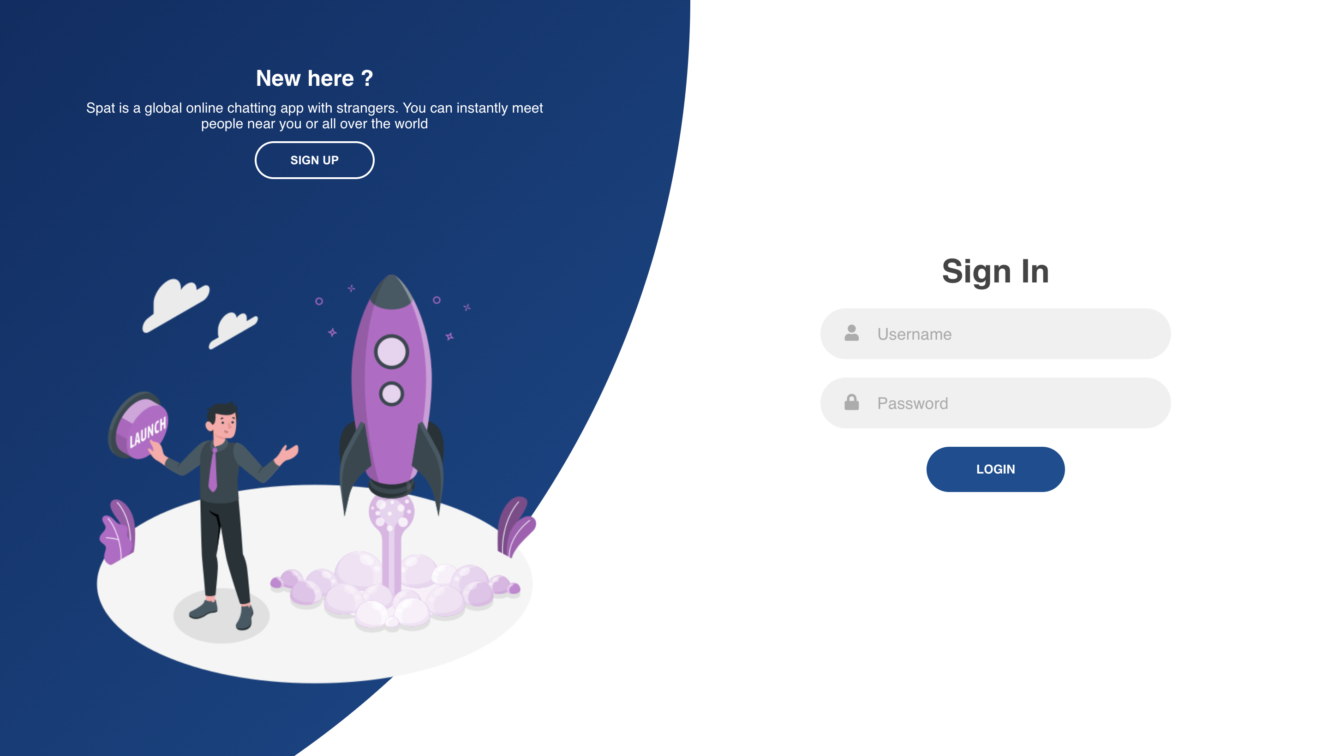

Sign in page

Enter email id and password login

For sign up and sign in we are using firebase

Firebase connection is done in two file

1 config.js

this is basically for connection info api key

2 firebaseconnector.js

this file is used to define what all services we are using of firebase and config them in this file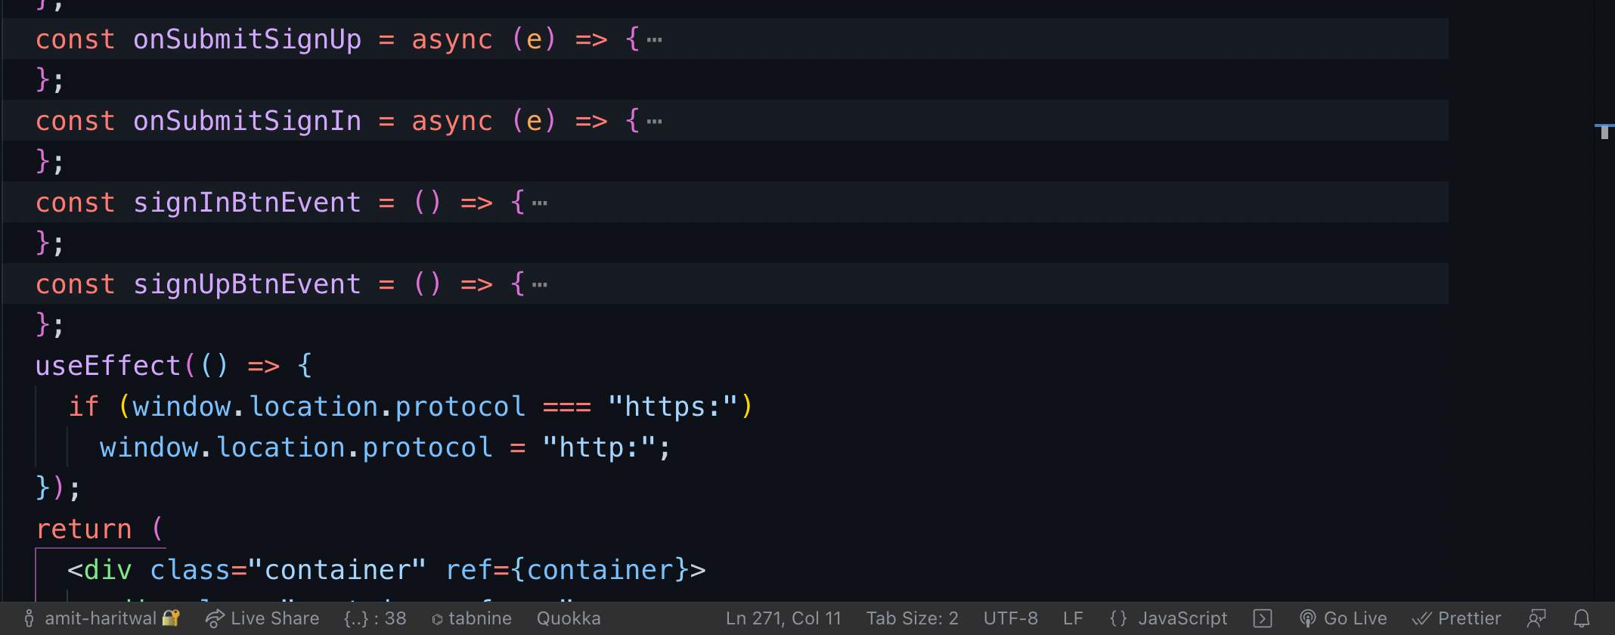

**Onsubmitsignup** function is used for storing signup info into firebase

**Onsubmitsignin** function is used for storing signin info into firebase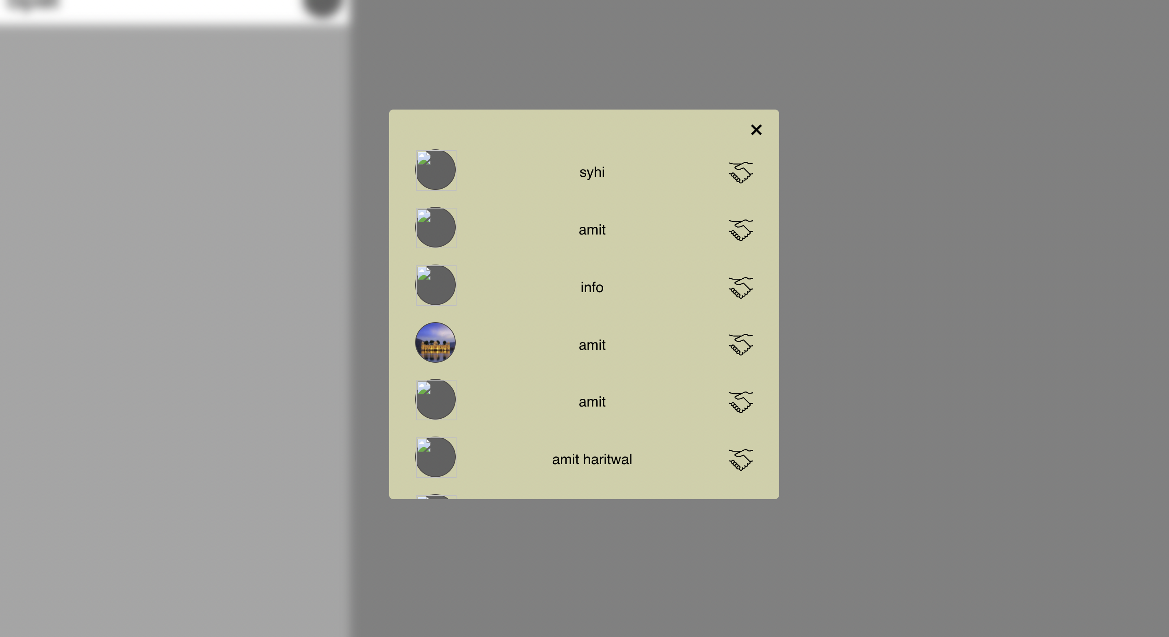

This page is used to get info of all the users trying to connect to users on website

**Addpartner.js**

this file is used to find all the users which are not connected to you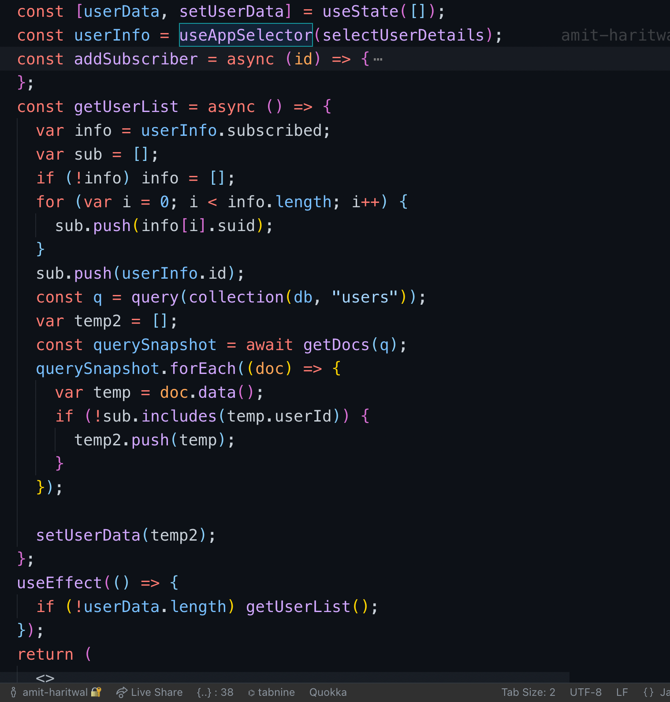

There are two function in this file one is getuserlist which is used to get all the info of users which are not connected to you on this platform and second is addSubscriber which is trigged when you click on hand shake button which is used to connect both of the users

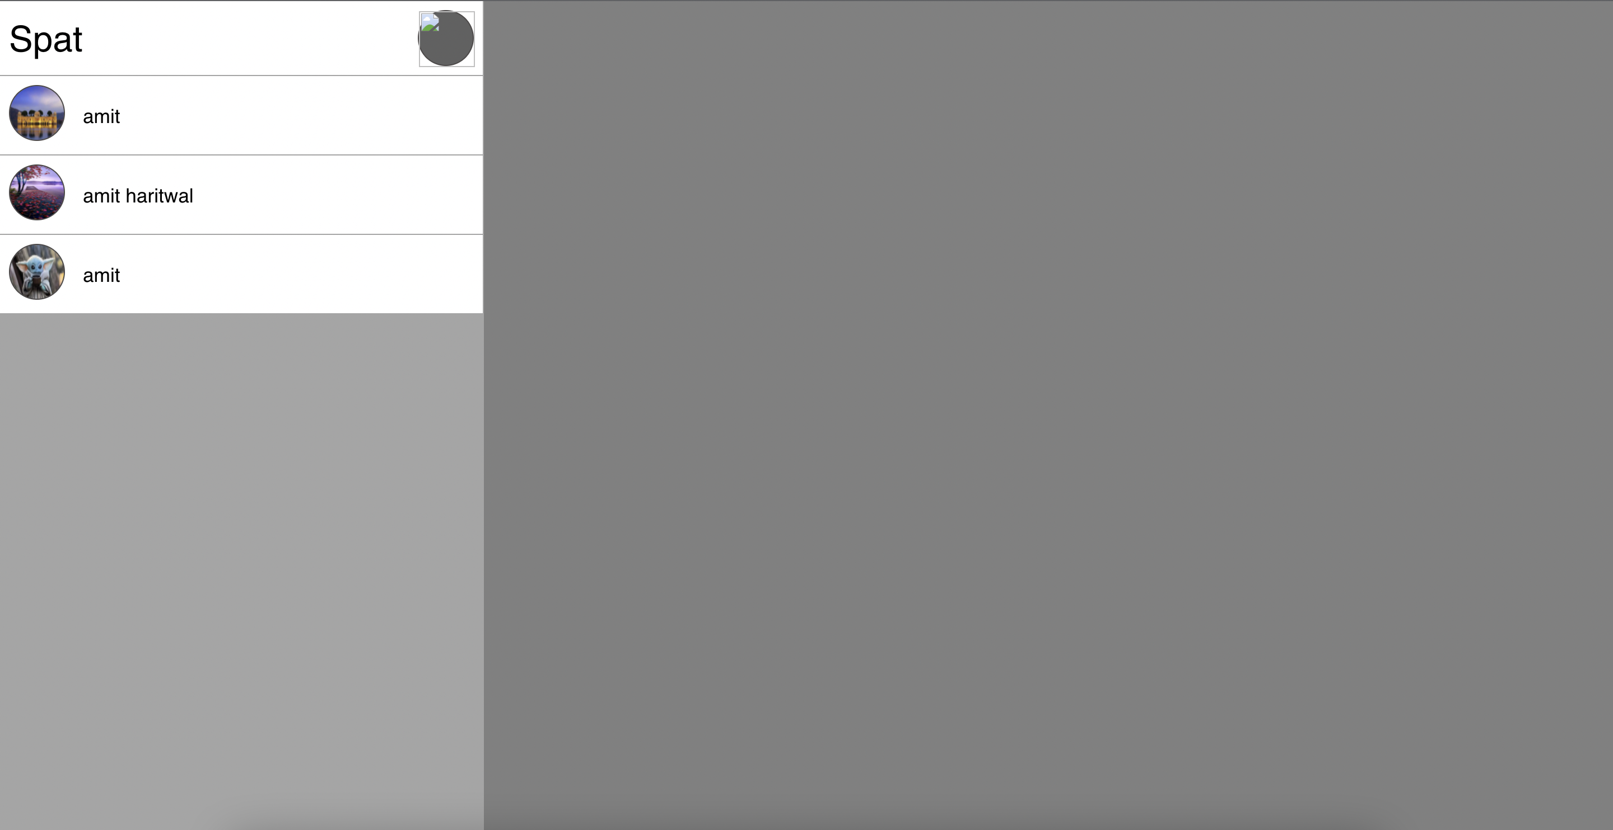

This page is the main page on the left side this list of connected users are there to which you are connected and to chat to them you have to click on that user only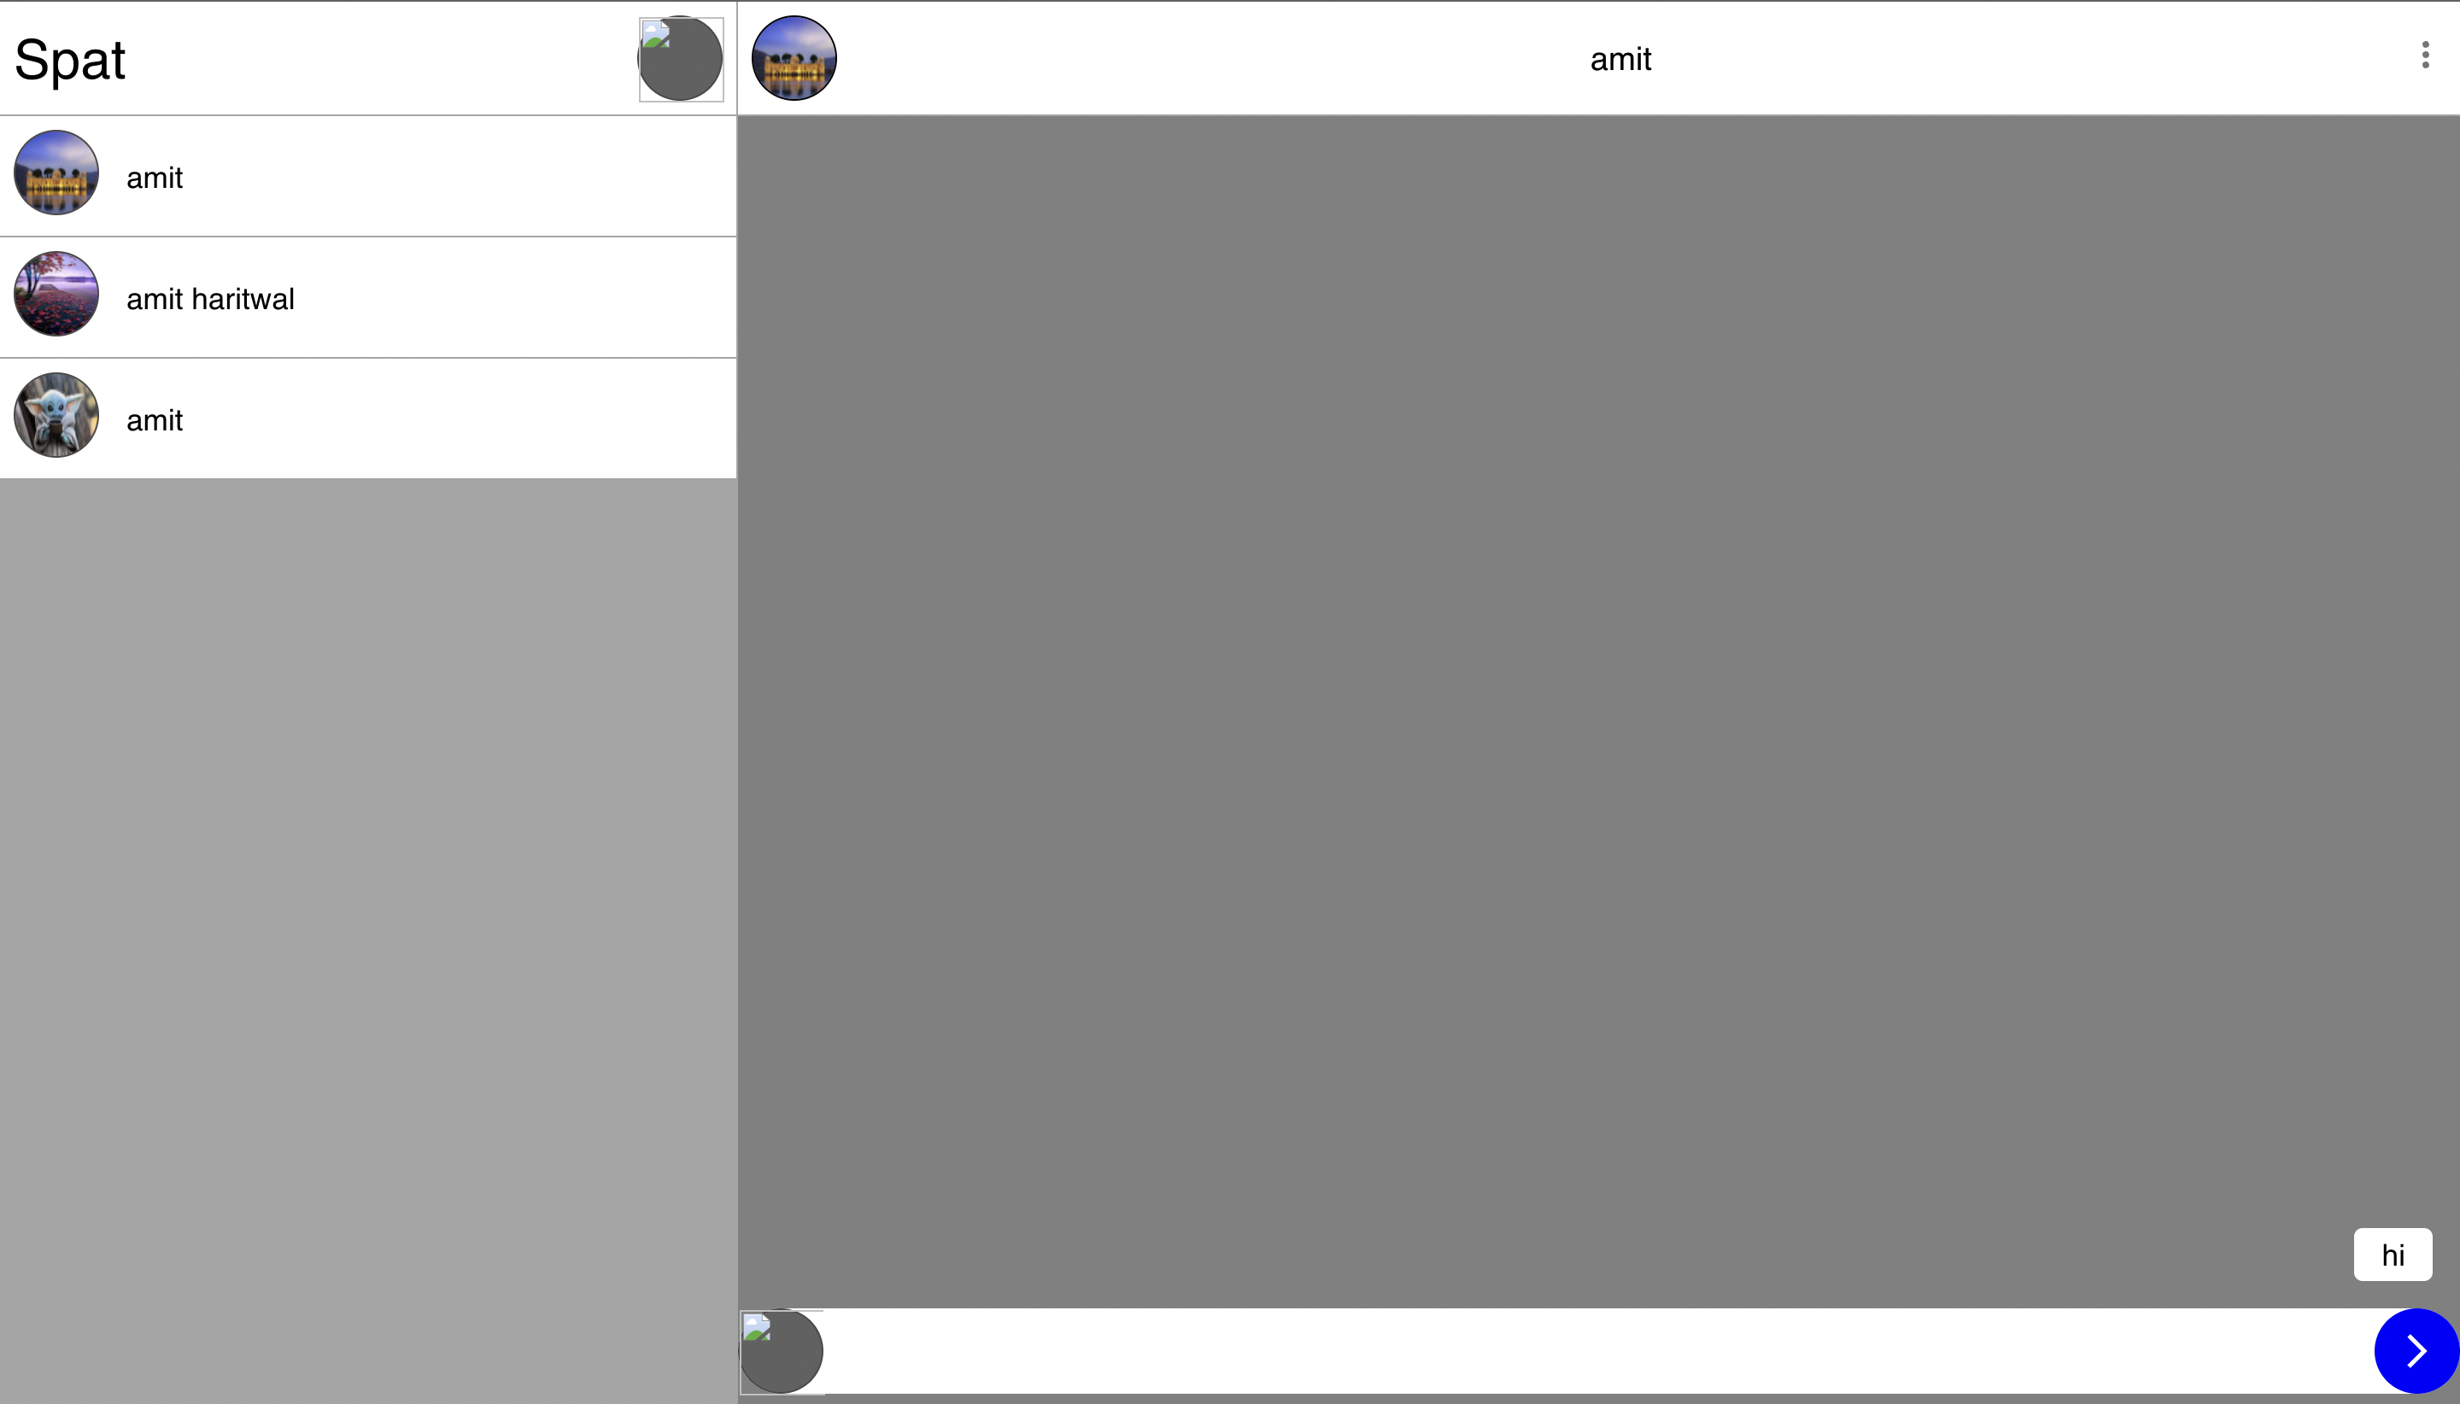

This is the right section which appears when you click on particular user on top you get the users profile with there name and on the bottom you have message input box and there is profile on left and submit button on right when you write and send a message then it will appear on right side and incoming message will appear on left side.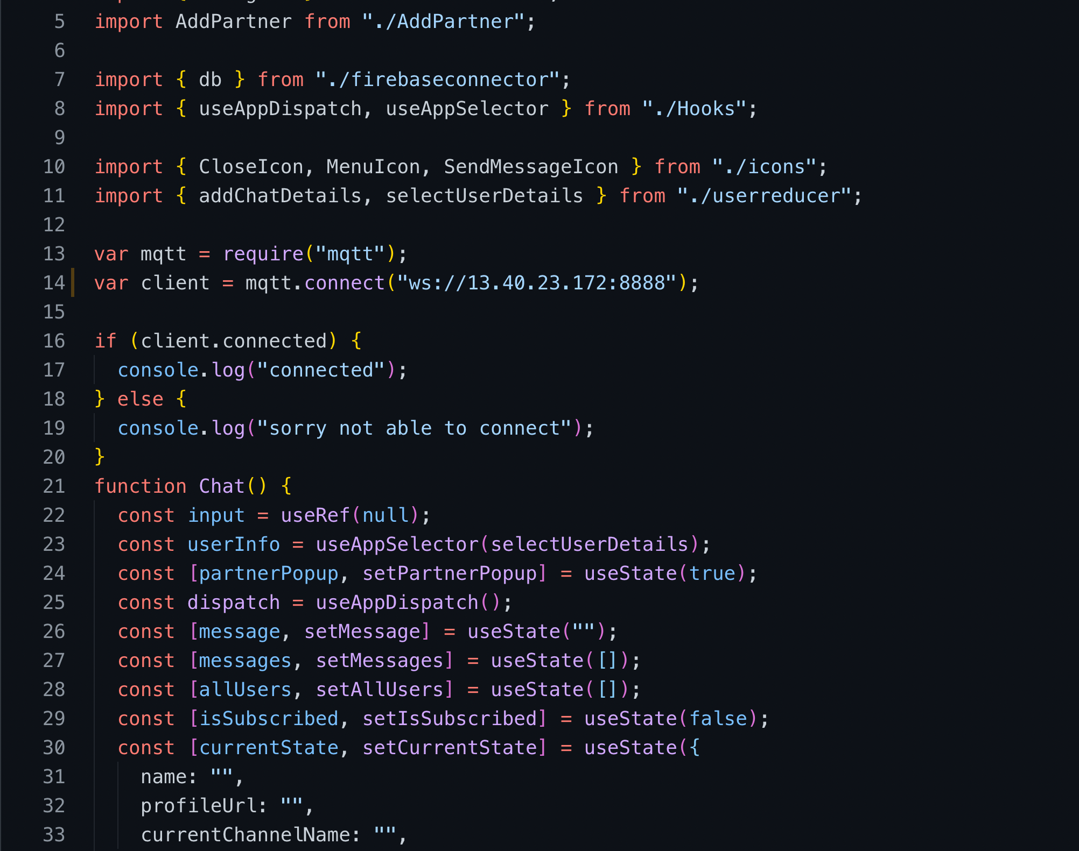

**Chat.jsx** is the file in which all the this are done first we connect to Matt broker using mqtt module and the link on line no 14 is the place where we connect to them

**getconnectioninfo** is used to get all the info of your connection with the help of user details which is stored in redux in details we are getting userId which is u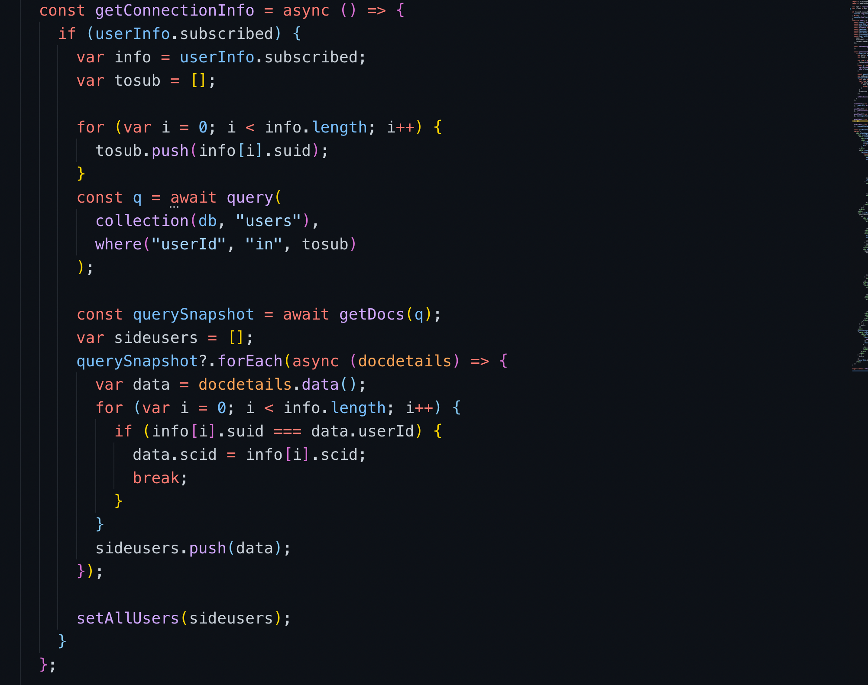sed to get user full details and connection id which is unique key which is combination of your id and your connection id by which we can identify who to show chat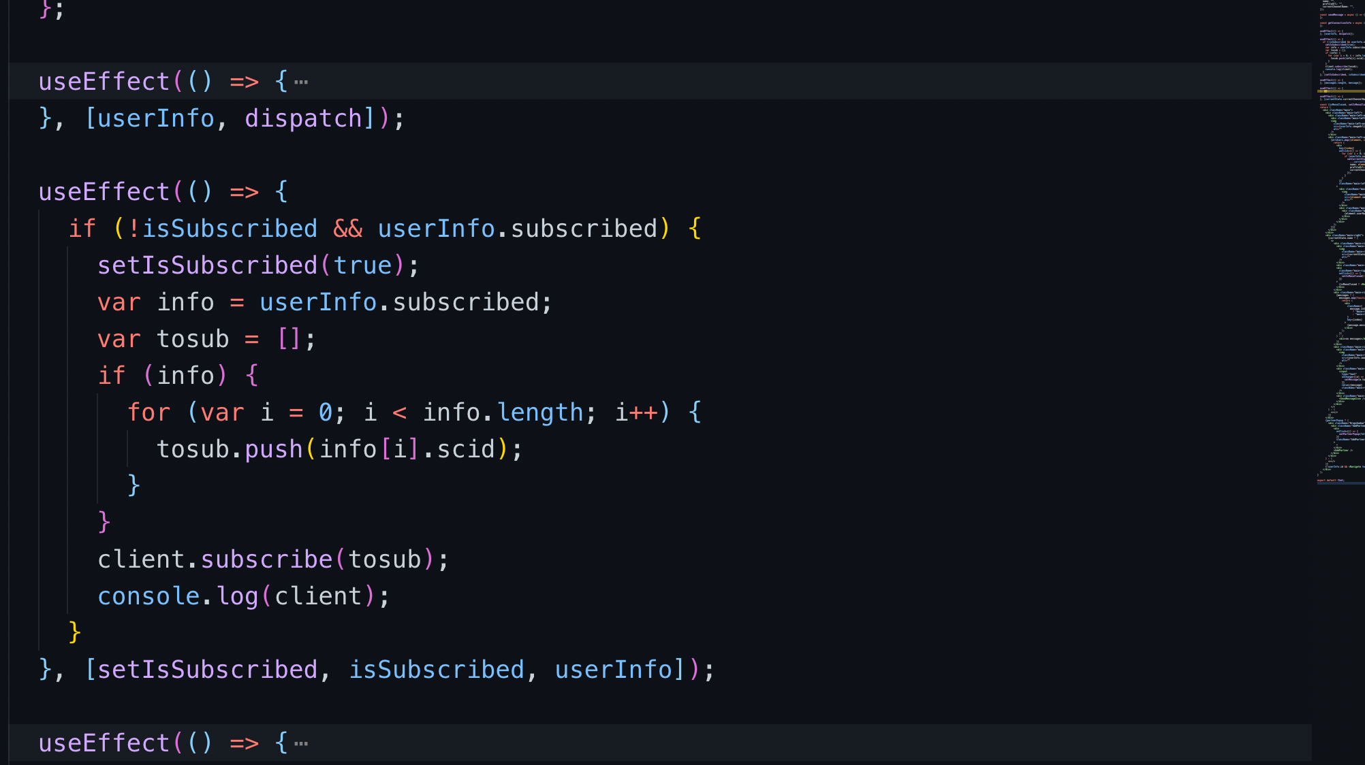

This useeffect is used to subscribe to all the connection whose details we got from get connection info

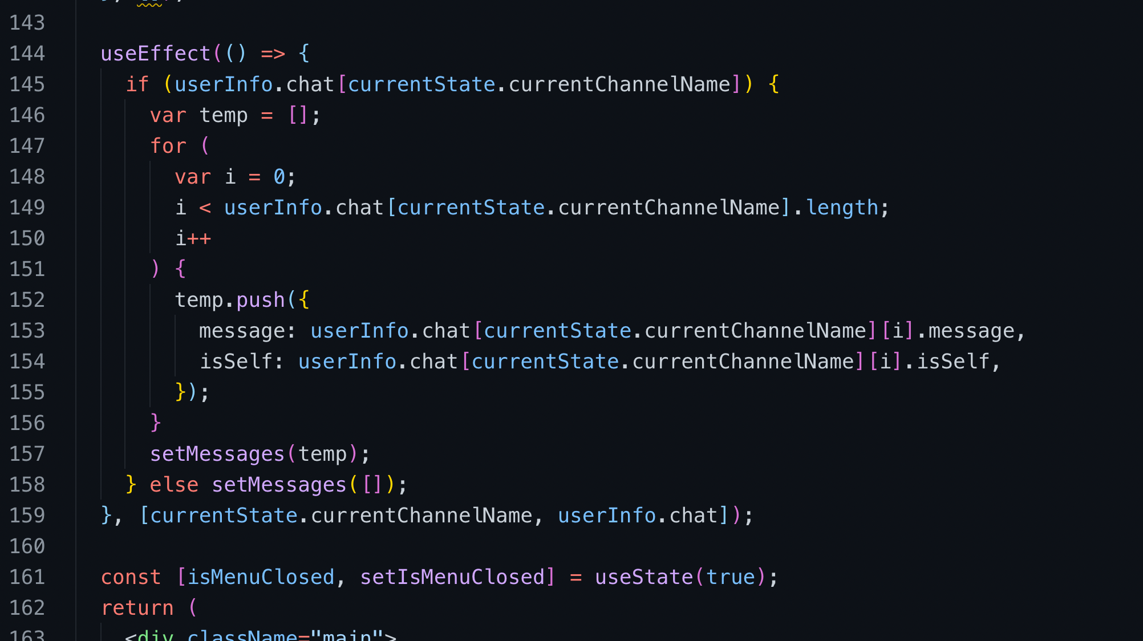

This use effect is used to push your chat to redux where we store chat. So that there is smooth transition between users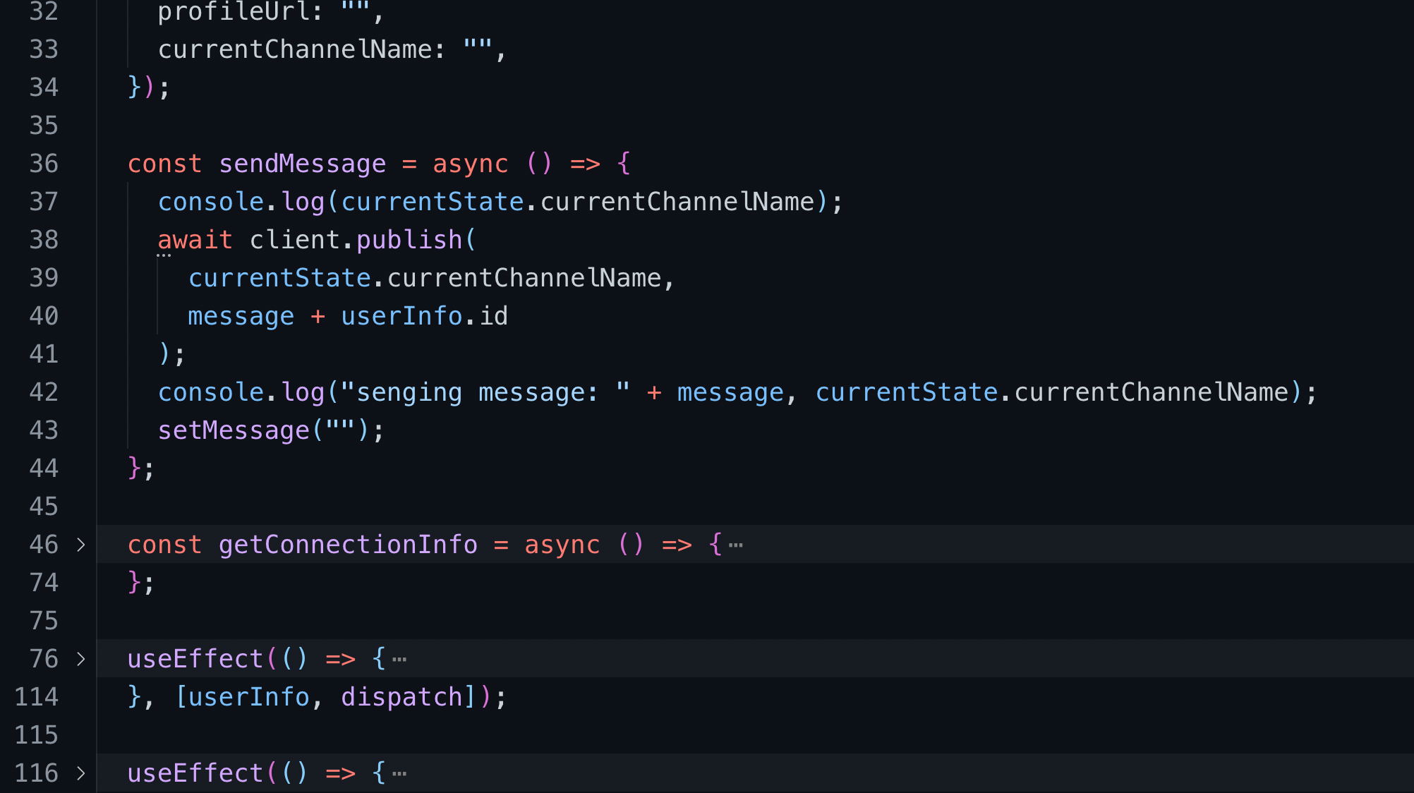

Send message is used to send message to that subscriber on which you recently clicked on left side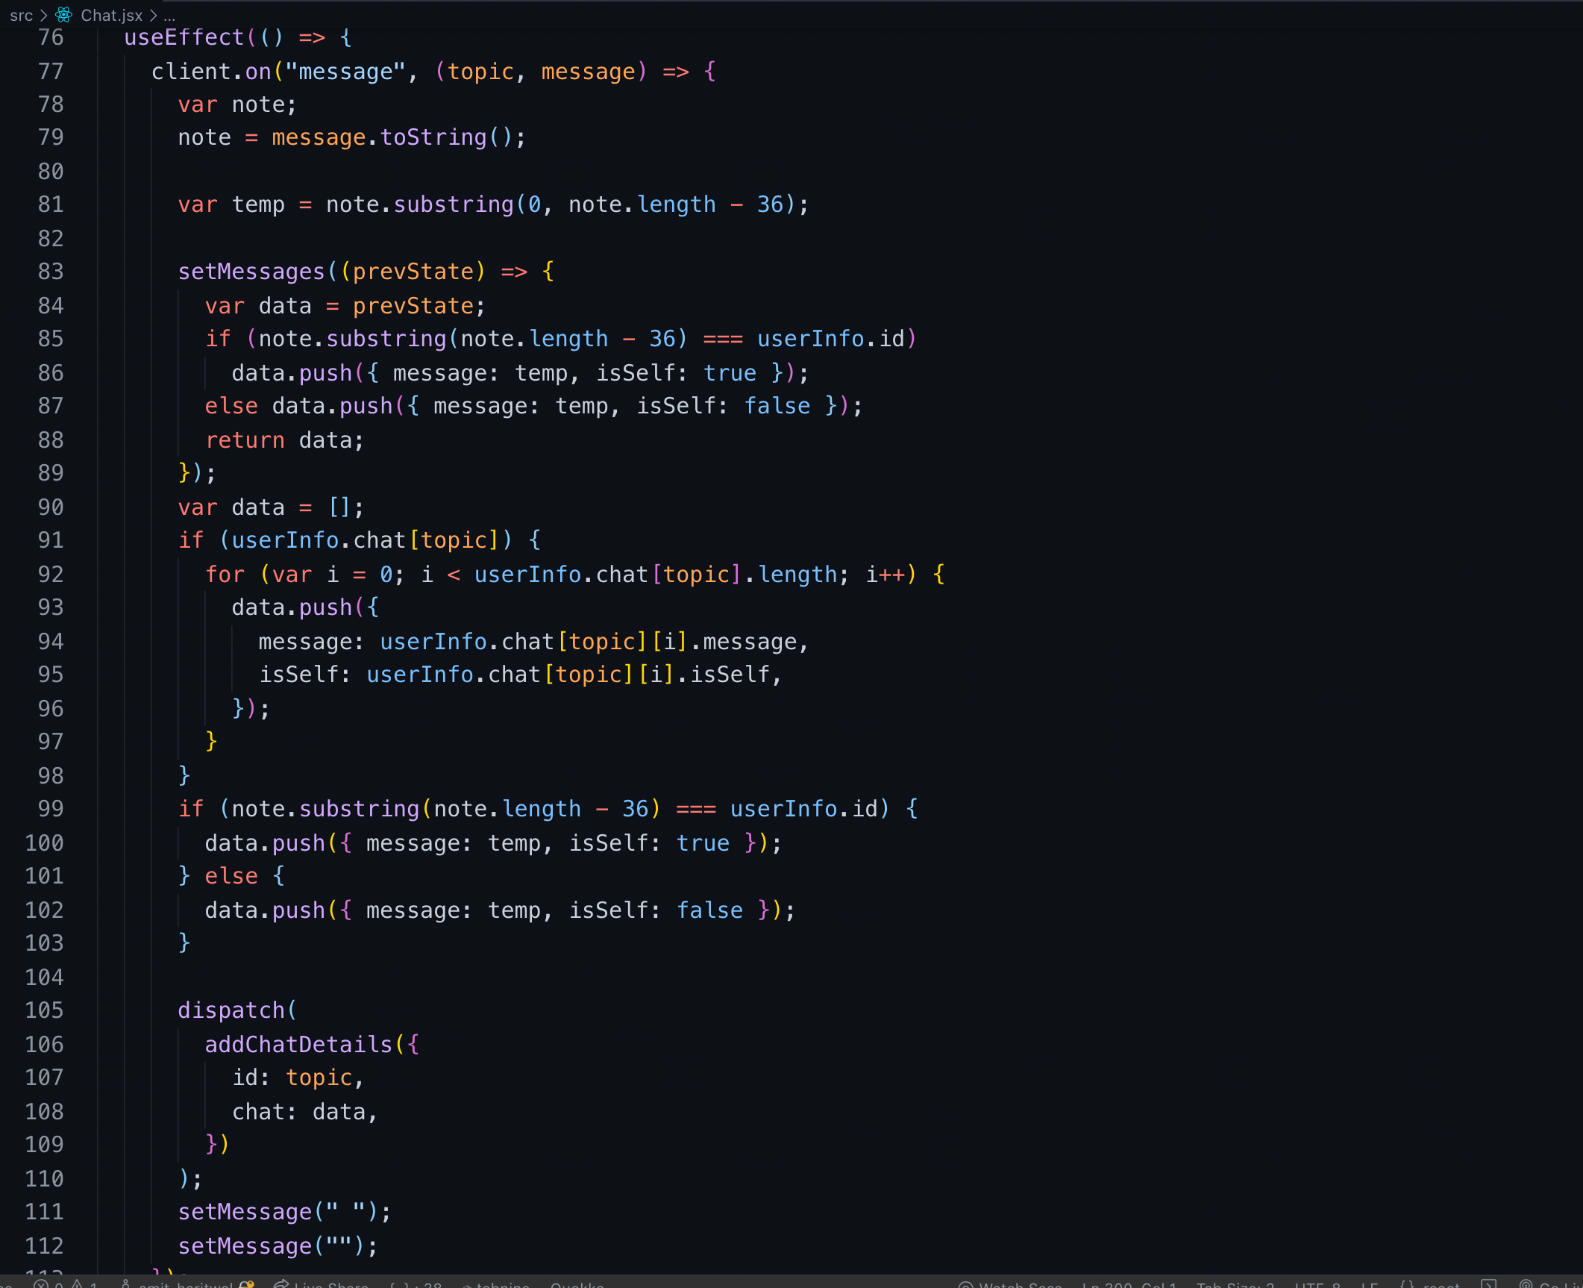

This is the most important part for chat this is basically to get chat info for Matt broker and we identify that it is my message or others message so that according to that we can put that to left or right and push that to redux

Router.js is basic routing done in react

This is redux info so there are two reducer on of them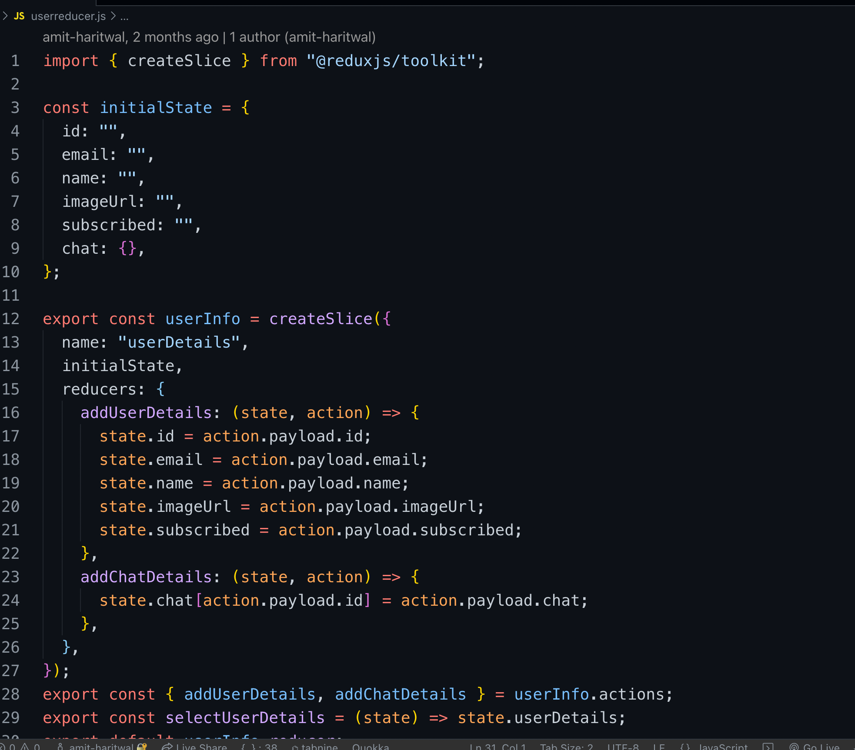 is to store user info and another is to store chat info